Easy Read response form

Making local government stronger
Choices for stronger and larger councils
Response Form existing
We want to know what you think. Please tell us by 12 June 2018

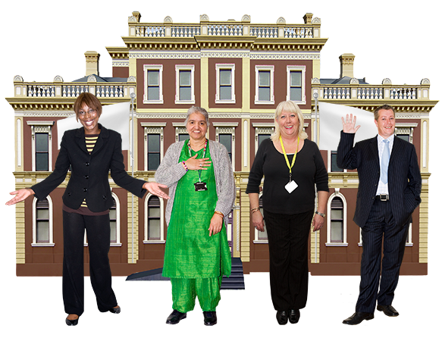

This is an easy read version of the questions from the Welsh Government Green paper consultation document: Strengthening Local Government: Delivering for People, March 2018

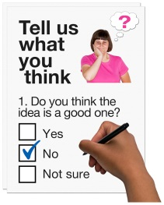
How to use this document
This form has questions about our ideas for making local government stronger.

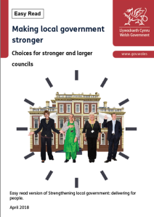
Before you answer the questions, please read Strengthening Local Government: Delivering for People, March 2018

Please try to explain your answers. And give your own thoughts and ideas too.

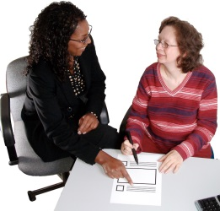
You may need support to read and understand this document. Ask someone you know to help you.

Some words may be difficult to understand. These are in bold blue writing and have been explained in a box beneath the word.

Where the document says we, this means the Welsh Government.

This document was made into easy read by Easy Read Wales using Photosymbols.
How we will use the information you give us
You will need to tell us your name and address to answer these questions. We may use any information about you when we plan in the future.
We will put out a copy of the answers people give us. We may put your name and address in this.
You can tell us you do not want your name and address put out.

Sometimes we have to put out your name and address. Even when you say you do not want us to. This does not happen very often. We will talk to you first about it.
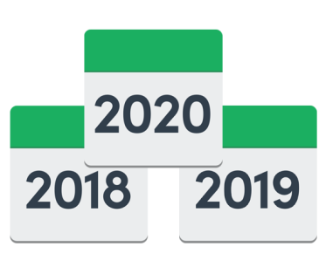

We will keep all your information for 3 years.

Do you want your name and address on the answers we put out?
Yes ☐ No ☐
How to answer
You can answer on the internet or in this booklet.

Please send your answer booklets to the address below. Or if you need more copies contact us at:
Strengthening Local Government
Welsh Government
Cathays Park
Cardiff
CF10 3NQ
or email your answers to:
StrengtheningLocalGov@gov.wales

About you
Your name

The organisation you are answering for

Email or telephone

Your address
Questions
Chapter 3 Choices for local government
Please look at pages 11 to 19 of the main document.
1a. What can we do to make services like social services and education work better in a region?
A region is a large area. Such as North East Wales

1b. What do you think about us joining some of the councils together?

1c. What do you think about the choices we have for changing to larger councils?
1d. Are there any other ways to change to larger councils that we need to think about?

Chapter 4 Where will the new local councils be?
Please look at pages 20 to 25 of the main document.

2a. Do you agree it is important to know where the new councils will be?
Yes ☐ No ☐ Do not know ☐

2b. Do you agree with the things we say are important when making this decision?
Yes ☐ No ☐ Do not know ☐

Is there anything you want to change or add?

2c. What do you think about the areas we suggest for the new councils?

2d. Do you have other ideas for where the new councils need to be?
Yes ☐ No ☐ Do not know ☐

If yes what makes you think this?

2e. Are there other ways we can make it simpler to work across a region? And to work between the new councils and other organisations like health and police?
Yes ☐ No ☐ Do not know ☐

If yes, please tell us your ideas.

Chapter 5: A clear and fair way forward
Please look at pages 26 to 31 of the main document.

3a. Do you agree with the way we want the change to happen?
Yes ☐ No ☐ Do not know ☐

3b. Looking at choice 1. Do you agree we need a date for councils to join together that fits with local elections?
Yes ☐ No ☐ Do not know ☐

3c. Do you have anything else to say about the change?

4. We suggest having local government elections in June 2021. Are there any good reasons this is not a good date?

Yes ☐ No ☐ Do not know ☐

If yes please give us another date and say why it is better.

5. There are lots of other plans and assessments which link to elections. We will make sure they fit in with new election dates. Is there anything else that fits in with elections we need to think about?

6. What do we need to ask the group who look at wards for elections to do?

Chapter 6 Making local government stronger and giving support through the changes
Please look at pages 32 to 43 of the main document.

7a. How can we make better use of what our councillors know about their community?

7b. What changes to councillors’ pay and support will encourage other people to stand as councillors?

8a. Does local government need other powers?
Yes ☐ No ☐ Do not know ☐

If yes, please tell us your ideas.

8b. Does local government need to be free to do other things?
Yes ☐ No ☐ Do not know ☐

If yes, please tell us your ideas.

9a. What will be the best things to buy with other councils to save most money?

9b. What is the best way to do this?

10a. We think all councils working in the same way is good for some things. How can we give good advice and support about this?
10b. What other difficulties or chances to improve have we not included here?

If these need support, what sort of support do they need?

10c. Think about the changes and how they affect staff and the work of councils. What are the most important things to do first?

11. We want to know how you think these changes will affect the use of Welsh. Especially when Welsh language is treated as equal to English language.

11a. What affect do you think all this will have on the Welsh language?

11b. How can we make good effects be bigger? And bad effects be smaller?
12. Is there anything more we can do with the changes to have:
- more ways for people to use Welsh
- using Welsh treated the same as using English
- people who use Welsh have the same chances as people who use English?

Do you have anything else you want to say about these changes?

Thank you for giving us your views.

