Easy Read

Questionnaire on helping people who are lonely and find it difficult to meet other people

Please tell us what you think by 15 January 2019
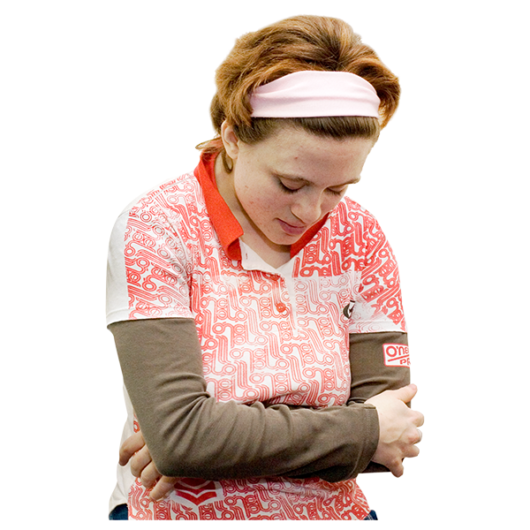

This is an easy read version of the questions from ‘Connected Communities: Tackling Loneliness and Social Isolation – Welsh Government Consultation Document’.

October 2018

How to fill in this questionnaire
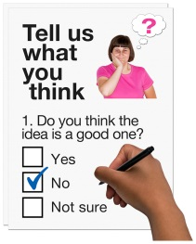
This questionnaire has questions about our ideas for helping people who are lonely and find it difficult to meet other people.

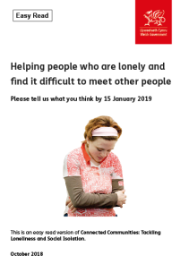
Before you answer the questions, please read the main easy read document: Helping people who are lonely and find it difficult to meet other people, October 2018.

Please try to explain your answers. And give your own thoughts and ideas too.

You may need support to read and understand this document. Ask someone you know to help you.

Some words may be difficult to understand. These are in bold blue writing and have been explained in hard words on page 41 of the main document.

Where the document says we, this means the Welsh Government.

This document was made into easy read by Easy Read Wales using Photosymbols.

Please send this form back to us by 15 January 2019.

By post:
Loneliness and Social Isolation Team
Social Services Directorate
Welsh Government
Crown Buildings
Cathays Park
Cardiff
CF10 3NQ
By email: lonelinessandisolation@gov.wales

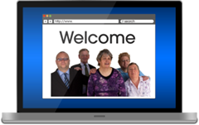
Or you can fill in the questionnaire on our website:
http://wales.gov.uk/consultations/?lang=en

How we will use the information you give us
Welsh Government will be looking at your answers to the questionnaire to make decisions about how to support people in the best way.

Sometimes we ask other organisations to help us make decisions. They may also see the answers that people gave to the questionnaire.
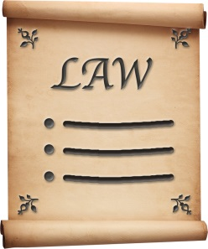

We will make sure we follow the law when you use your information.

We will write a report about what people said.

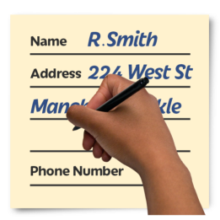
We might write some people’s answers in full with their names and addresses in the report or on the internet.
When you send us your answers, please tell us if you do not want us to write your name and address in the report or on the internet.

The data protection laws give you the right to:

- Know what information we have about you and how you can see it.

- Make us change any mistakes in the information about you.

- Ask us not to use the information in some cases.

- Ask us to delete the information we have about you in some cases.

- Move the information about you somewhere else in some cases.

- Complain to the Information Commissioner’s Office.

If you would like to know more about how your information is kept and used please contact us at:

Data Protection Officer
Welsh Government
Cathays Park
CARDIFF
CF10 3NQ

Email: Data.ProtectionOfficer@gov.wales

You can also contact the Information Commissioner’s Office:
Wycliffe House
Water Lane
Wilmslow
Cheshire
SK9 5AF

Tel: 01625 545745 or 0303 123 1113

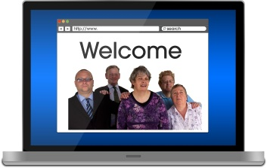
Website: https://ico.org.uk
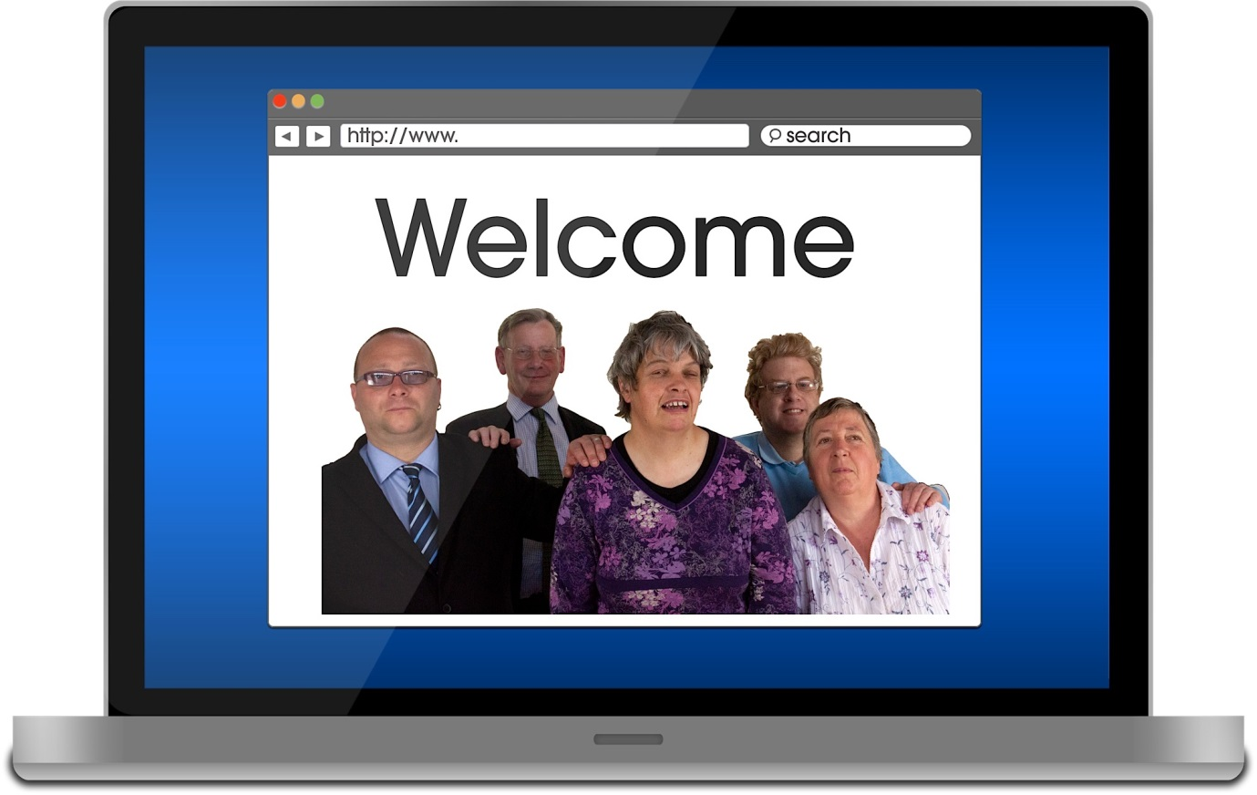

About you
Your name:

The organisation you are answering for or with:

Your email address:

Your address:

Do you want your name and address on the answers we send out?

Yes | ☐ |  | No | ☐

Questions
What is loneliness and social isolation?

Please look at section 3 on page 13 of the main document.

- Do you agree with how we described loneliness and social isolation? Please tick 1 box.

Yes | ☐ | No | ☐ | Not sure | ☐

If you ticked No or Not sure, how would you describe loneliness and social isolation?

The causes of loneliness and social isolation in Wales

Please look at section 5 on page 16 of the main document.

- a) How can we help people understand what causes loneliness and social isolation?

- b) How can we help people do things to stop them being lonely or socially isolated?

The job of Welsh Government

Please look at section 6 on page 21 of the main document.

- What can the Welsh Government do to help communities make sure people are not lonely or socially isolated?

The work we are doing now

Early years and education

Please look at section 7 on page 22 of the main document.

- How can we make sure children and young people have good relationships?

- How can we make sure schools support children and young people who are lonely or socially isolated?

Housing

Please look at section 7 on page 23 of the main document.

- a) What can housing organisations do to help stop loneliness and social isolation?

- b) What can Welsh Government do to support housing organisations with this?

Public transport

Please look at section 7 on page 24 of the main document.

- What can Welsh Government do to make public transport better?

Using the internet

Please look at section 7 on page 25 of the main document.

- a) What can we do to help more people use computers and the internet?

8. b) How can we make sure people can use the internet safely?

Social care

Please look at section 7 on page 25 of the main document.

- Can you tell us about any ways that social services have tried to help people who are lonely or socially isolated?

- What can social care services do to help stop loneliness and social isolation?

Health

Please look at section 7 on page 26 of the main document.

- What can we do to get people who might be lonely or socially isolated to take part in local groups and do more exercise?

Mental health

Please look at section 7 on page 27 of the main document.

- How can health services do more to help stop loneliness and social isolation?

Volunteering

Please look at section 7 on page 28 of the main document.

- What can Welsh Government do to get more people to volunteer?

- a) What can charities and community groups do to help stop loneliness and social isolation?

- b) How can Welsh Government help charities and community groups with this?

Skills and jobs

Please look at section 7 on page 30 of the main document.

- What can employers and companies do to help stop loneliness and social isolation?

Poverty

Please look at section 7 on page 31 of the main document.

- What can Welsh Government do to help people who are lonely or socially isolated because of poverty?

Where you live

Please look at section 7on page 35 of the main document.

- What else can we do to make communities stronger? And support communities to help stop people becoming lonely or socially isolated?

Our plan

Please look at section 9 on page 38 of the main document.

- Do you agree with our plans? Please tick 1 box.
Yes | ☐ | No | ☐ | Not sure | ☐

If you ticked No or Not sure, what do you think we should be doing instead?

- Do you know of any other work being done in Wales or anywhere else that has helped people who are lonely or socially isolated?

Finding out how lonely or socially isolated people in Wales are

Please look at section 10 on page 39 of the main document.

- Do you know of other ways we can learn more about how many people are lonely or socially isolated?

Welsh

We want to know how our plans to stop loneliness and social isolation might affect people who speak Welsh.

- Do you think our plans will be good for people who speak Welsh? Please tick 1 box.
Yes | ☐ | No | ☐ | Not sure | ☐

Please tell us why.

- How could we make sure our plans are good for people who speak Welsh?

Anything else

- If you have anything else you would like to tell us about loneliness and social isolation in Wales, please tell us here.

