Easy Read

The Draft Additional Learning Needs Code – response form
We want to know what you think
Please send this response form back to us by
22 March 2019
This is an easy read version of the questions from Welsh Government’s: The Draft Additional Learning Needs Code Consultation Document – Children and Young People Version, December 2018
© Crown Copyright December 2018
WG36741
How to fill in this response form
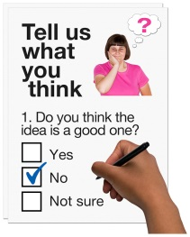
These questions are about our ideas for the Additional Learning Needs Code.

Before you answer the questions please read the main easy read document:

The Draft Additional Learning Needs Code Consultation Document - we want to know what you think, December 2018.

Please try to explain your answers. And give your own thoughts and ideas too.

You may need support to read and understand this document. Ask someone you know to help you.

Some words may be difficult to understand. These are in bold blue writing and have been explained in Hard words on page 29 of the main document.

Where the document says we, this means the Welsh Government.
This document was made into easy read by Easy Read Wales using Photosymbols.

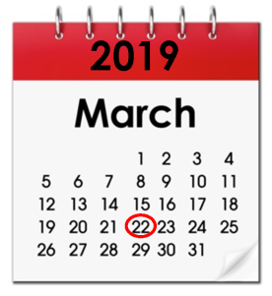
Please send this form back to us by 22 March 2019.

By post:
Additional Learning Needs Transformation Branch
Support for Learners Division
The Education Directorate
Welsh Government
Cathays Park
Cardiff
CF10 3NQ
By email: SENreforms@gov.wales

How we will use the information you give us
Welsh Government will be looking at your answers to make decisions about the ALN Code.

Sometimes we ask other organisations to help us make decisions. They may also see the answers that people gave to the questionnaire.
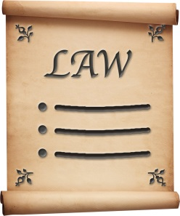

We will make sure we follow the law when we use your information.

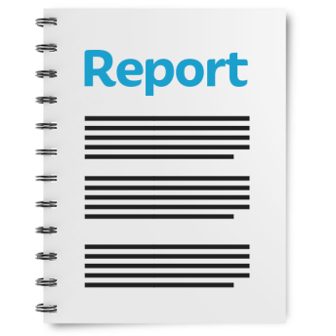

We will write a report about what people said.

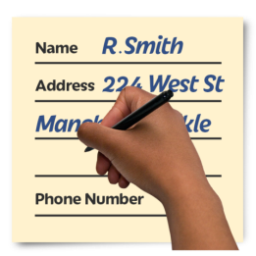
We might write some people’s answers in full with their names and addresses in the report or on the internet.
When you send us your answers, please tell us if you do not want us to write your name and address in the report or on the internet.

The data protection laws give you the right to:

- Know what information we have about you and how you can see it.

- Make us change any mistakes in the information about you.

- Ask us not to use the information in some cases.

- Ask us to delete the information we have about you in some cases.

- Move the information about you somewhere else in some cases.

- Complain to the Information Commissioner’s Office.

If you would like to know more about how your information is kept and used please contact us at:

Data Protection Officer
Welsh Government
Cathays Park
CARDIFF
CF10 3NQ

Email: Data.ProtectionOfficer@gov.wales

You can also contact the Information Commissioner’s Office:
Wycliffe House
Water Lane
Wilmslow
Cheshire
SK9 5AF

Tel: 01625 545745 or 0303 123 1113

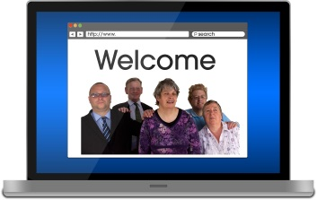
Website: https://ico.org.uk

We would like to share your answers with other people.

Please tick the box below if you want your answers to be kept secret:

☐

Please have a parent or guardian sign here if you are under 18:

Questions

Question 1 - do you think the ways we want people to work are right?

Please read ‘Important ideas for the new law’ – page 7 of the main document.

Question 2 - do you like our other ideas for what the plan must say?
Please read ‘A plan for each child and young person with ALN’ – pages 8 to 10 of the main document.

Question 3 - do you have any other ideas about what the plan should say?
Please read ‘A plan for each child and young person with ALN’ – pages 8 to10 of the main document.

Question 4 - what do you think about how long schools, colleges and local authorities have to write plans?
Please read ‘A plan for each child and young person with ALN – Getting a plan’ – pages 11 and 12 of the main document.

Question 5 - what do you think about giving people no more than 6 weeks to give local authorities information?
Please read ‘A plan for each child and young person with ALN – Getting information to write plans’ – page 13 of the main document.

Question 6 - what do you think about giving health services no more than 6 weeks to say if they can help?
Please read ‘A plan for each child and young person with ALN – Finding out if health services can help’ – page 14 of the main document.

Question 7 - what do you think about how long schools, colleges and local authorities will have to review plans?
Please read ‘Changing the plan – When something has changed’ – pages 15 and 16 of the main document.

Question 8 - what do you think about how long local authorities will have to check plans written by schools?
Please read ‘Changing the plan – When children, parents or young people are not happy’ – pages 16 and 17 of the main document.

Question 9 - what do you think about our ideas for what local authorities should do to stop and sort out disagreements?
Please read ‘Disagreements about plans – When children, parents and young people disagree’ – pages 18 and 19 of the main document.

Questions 10 - what do you think about our ideas for what local authorities should do to make sure advocates are doing a good job?
Please read ‘Disagreements about plans – Advocacy’ – pages 20 and 21 of the main document.

Question 11 - what do you think about our ideas of what should happen when a disagreement is taken to the Education Tribunal for Wales?
Please read ‘Disagreements about plans – Asking the Tribunal to decide what is right’ – pages 22 to 25 of the main document.

Question 12 - what do you think about children, parents and young people having 8 weeks to ask the Tribunal for help and to send in their case?
Please read ‘Disagreements about plans – Asking the Tribunal to decide what is right’ – pages 22 to 25 of the main document.

Question 13 - what do you think about local authorities and colleges having 4 weeks to write a case to explain why they think they are right?
Please read ‘Disagreements about plans – Asking the Tribunal to decide what is right’ – pages 22 to 25 of the main document.

Question14 - do you think it is important that ALNCos are teachers or someone who is already a SENCo?
Please read ‘Additional Learning Needs Coordinators – Who should be an ALNCo’ – page 26 of the main document.

Questions 15 - do you think these are the right things for ALNCos to do to best support children and young people with ALN?
Please read ‘Additional Learning Needs Coordinators – What ALNCos should do’ – pages 27 and 28 of the main document.

